Design Book Review –

My first observation is related to my Fitbit a wearable device. This is a fitness device that helps you to track walking, running, sleeping patterns, weight tracking, water intake, activity goals (by steps, by hour, by days and so on, it gives reminders etc) there is also a “challenge” feature with a social aspect where you invite others to participate on a way of a fun competition.

The usability is based on two components, one is the actual wearable device and the second is the app that connects via Bluetooth to update the readings from the device into the dashboard of the Fitbit app.
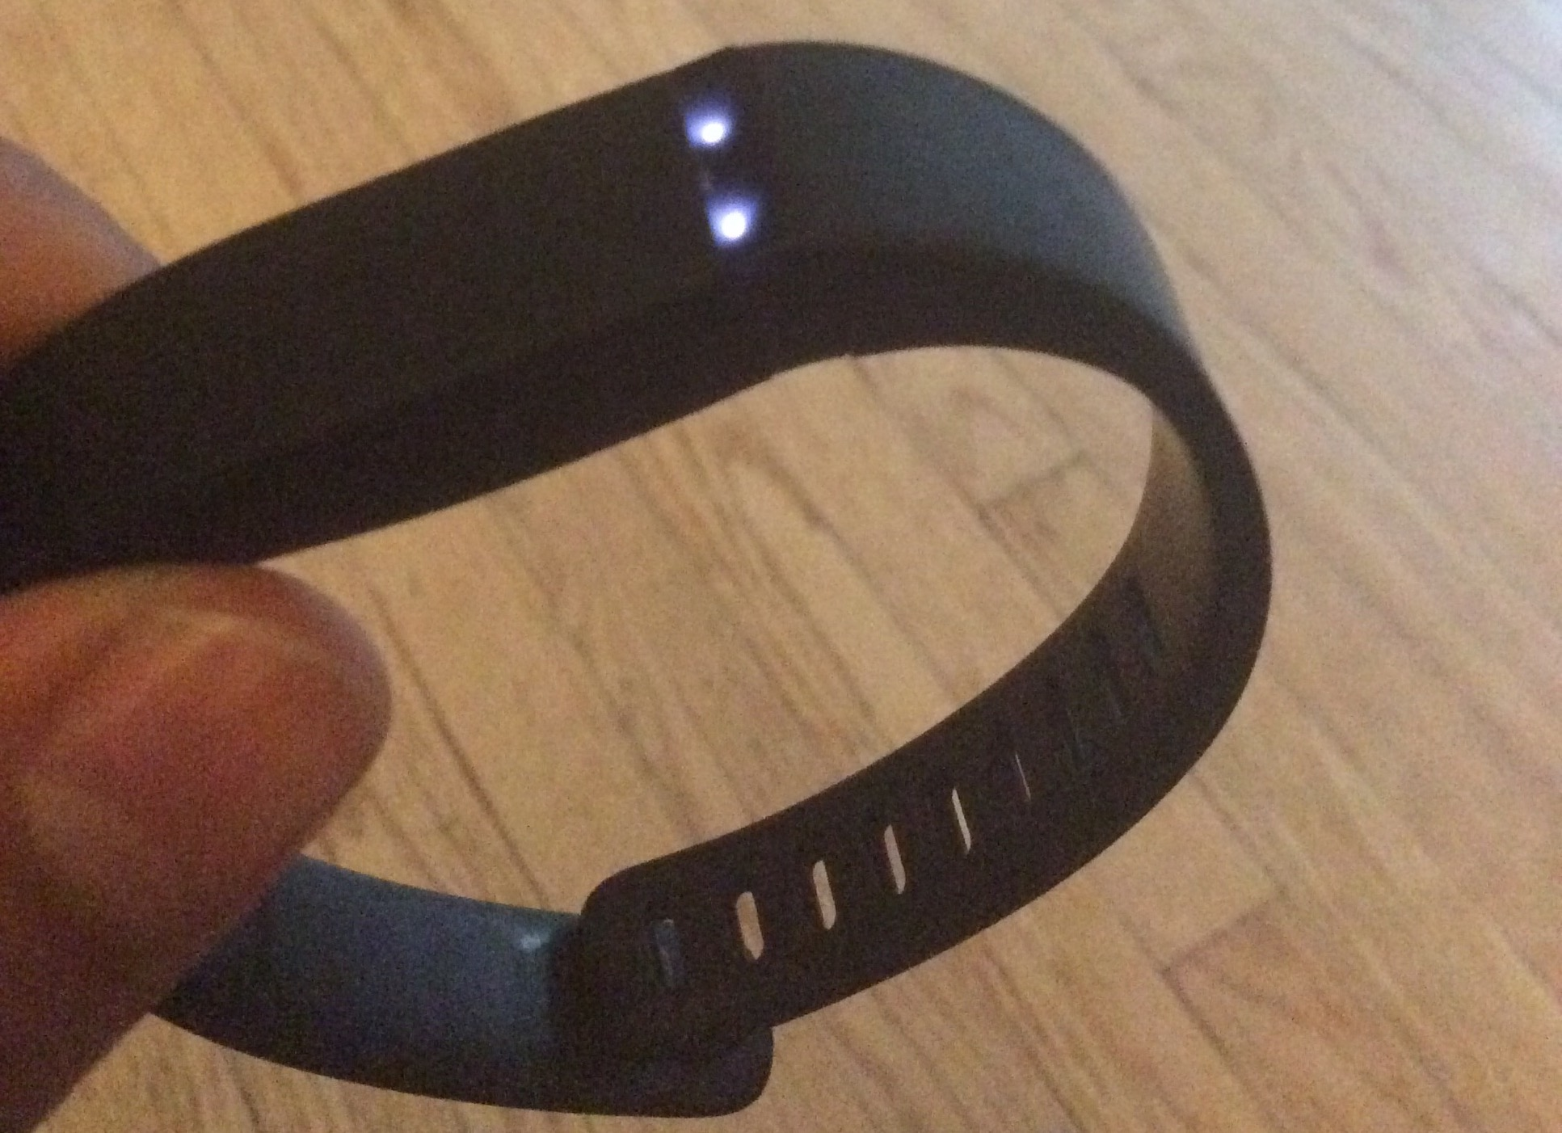
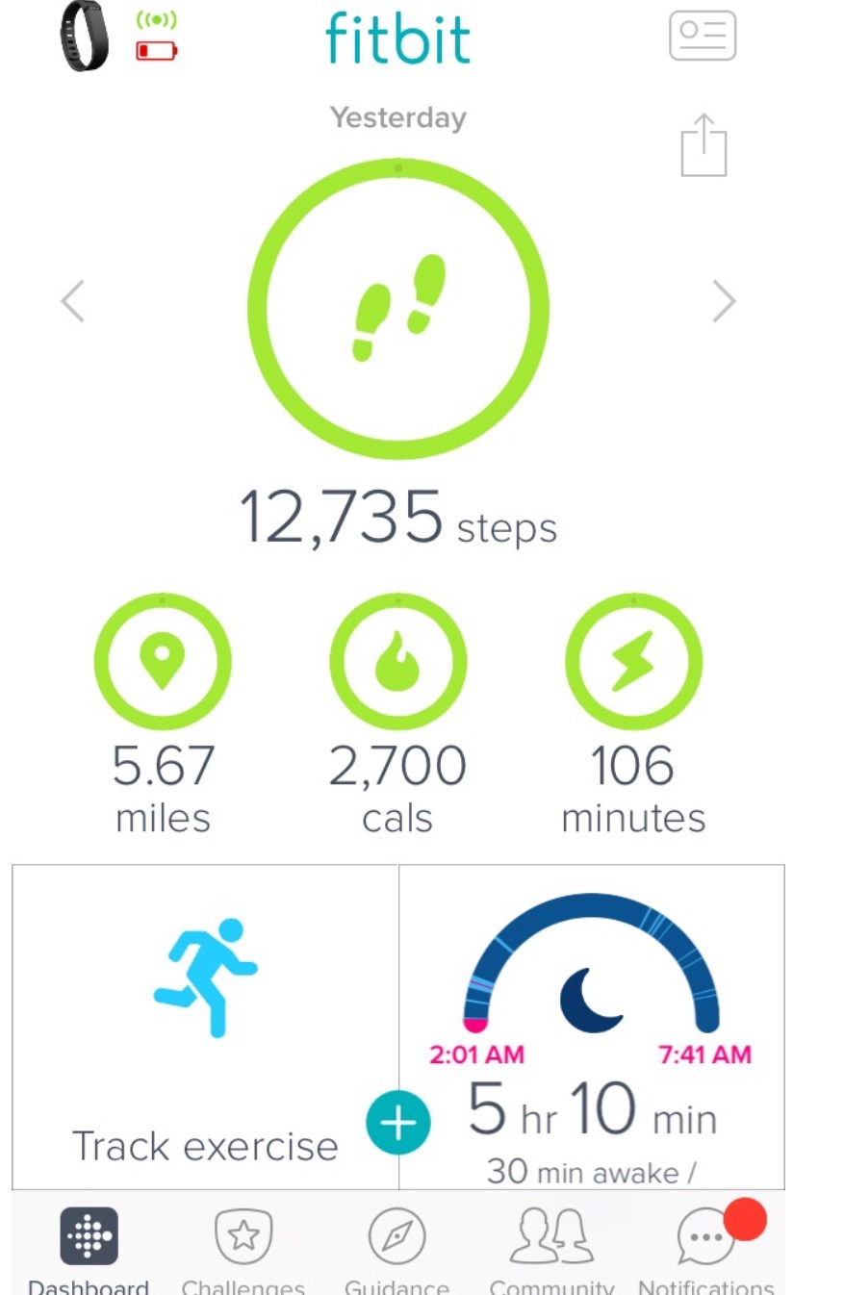

The usefulness of the device is very good, you wear it and that's it. Fitbit tracks things as expected, you don't have to do anything to the bracelet, one tap on the device and will display the percentage done so far of your activity on a form of lights. Two taps on the device and your are telling the device that you are going to bed. However, you need to use the dashboard to enter food and water intake, verify battery level, messages and progress.

The design is to my view simple and very minimalistic which I really like, compared to iwatch or garmin, Fitbit the perfect size. The app could use some updating, the icons are somewhat old and the dashboard for challenges should have more social options. Fitbit does have few flaws such as the lack of battery warning from the device currently the only two options are either via email or by synchronizing via Bluetooth to the app and a warning will display that it needs charging. My observation is that Fitbit has a good design overall, is intuitive to use and is simple.

Second Observation -

Following Instructions to make observations, another application that I use frequently with my class and have found few issues is CANVAS, use their app for my iPad and noticed that when I'm try to open links from the Syllabus, nothing is displayed, however using CANVAS website that is not a problem

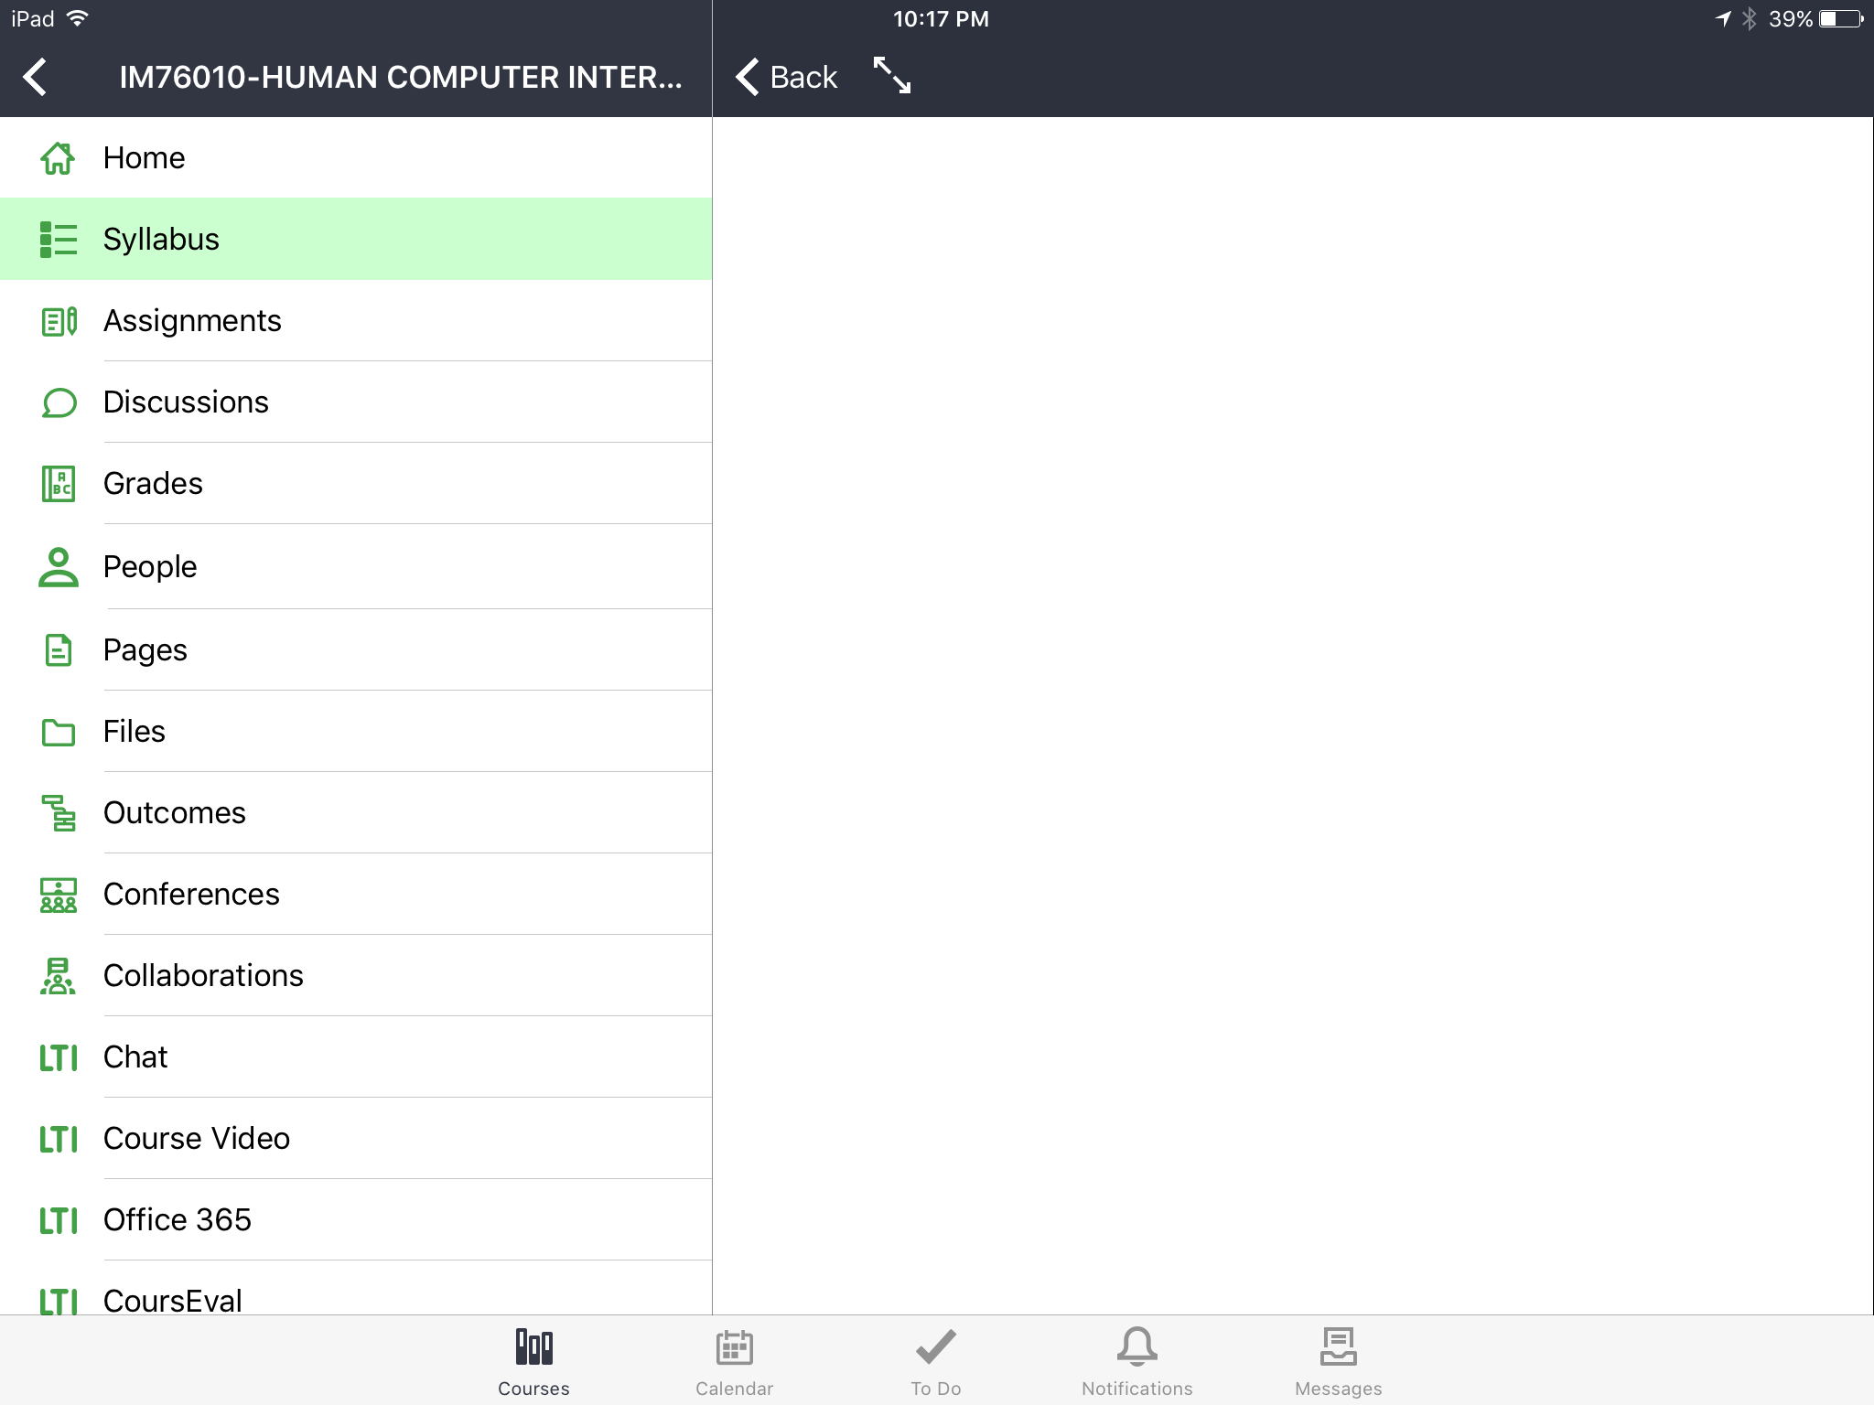
Another issue I found is that when opening a PowerPoint presentation thru the app like below
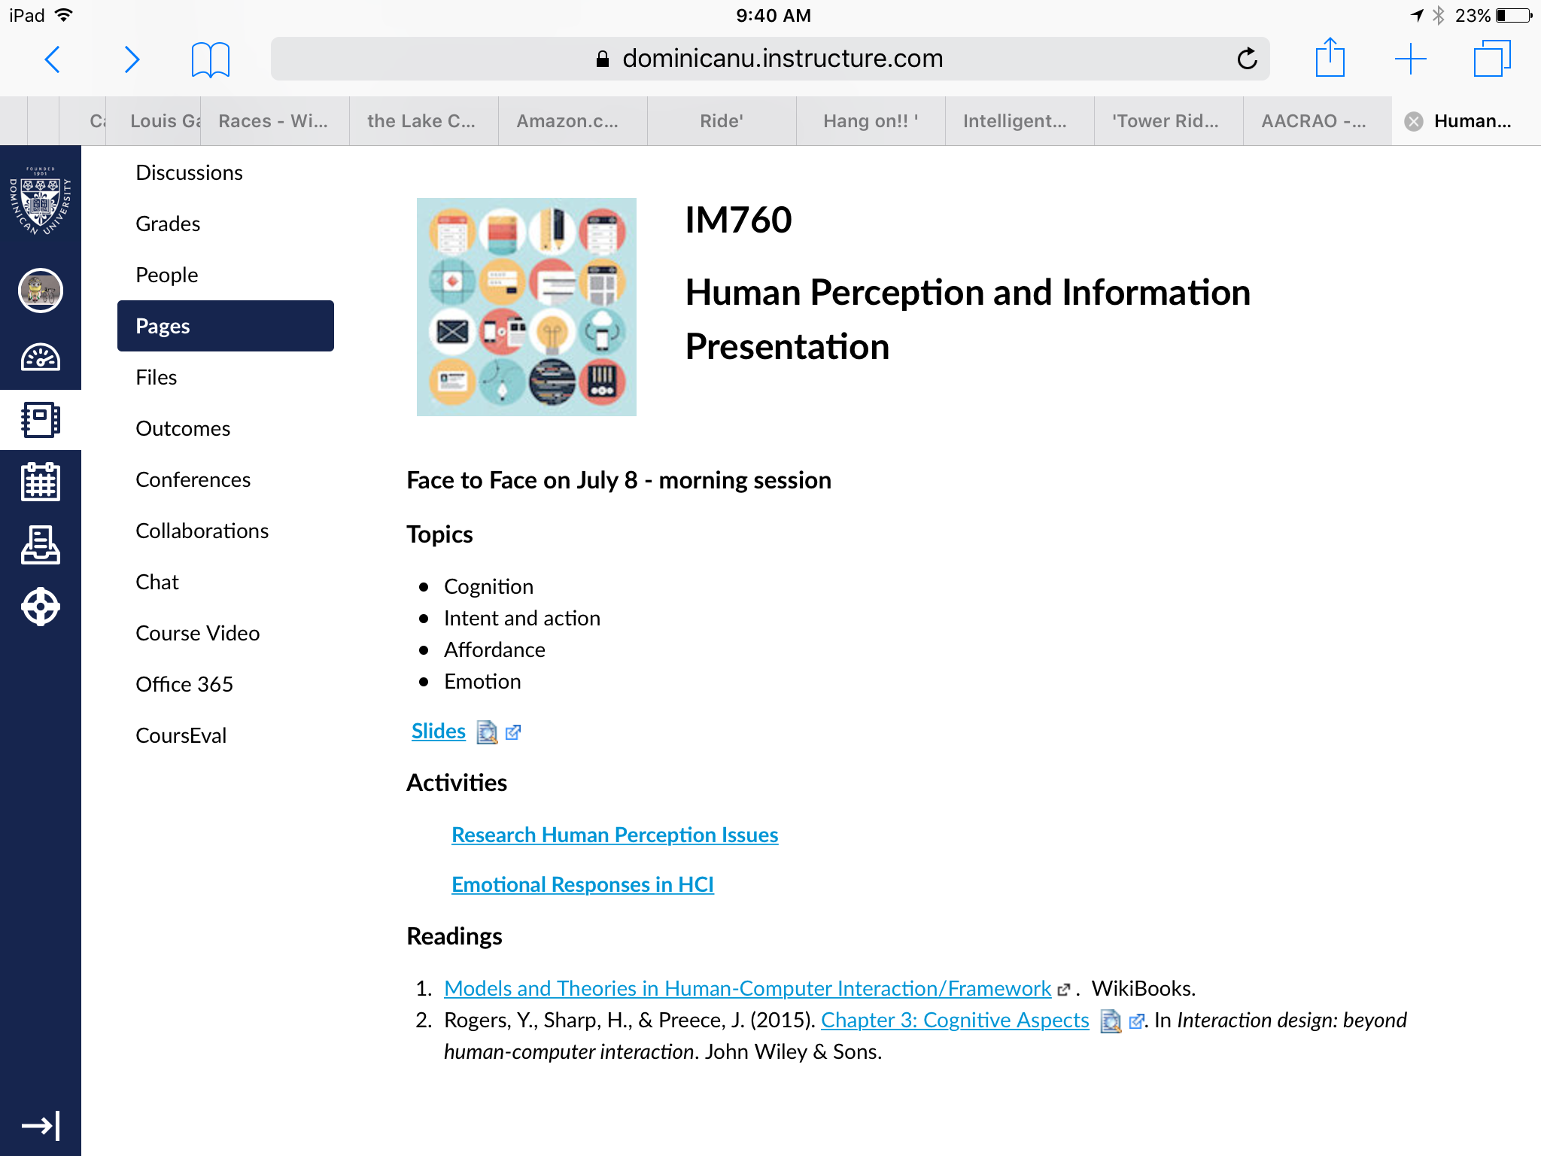
The slides of the presentation are not displayed properly, almost cut in half:

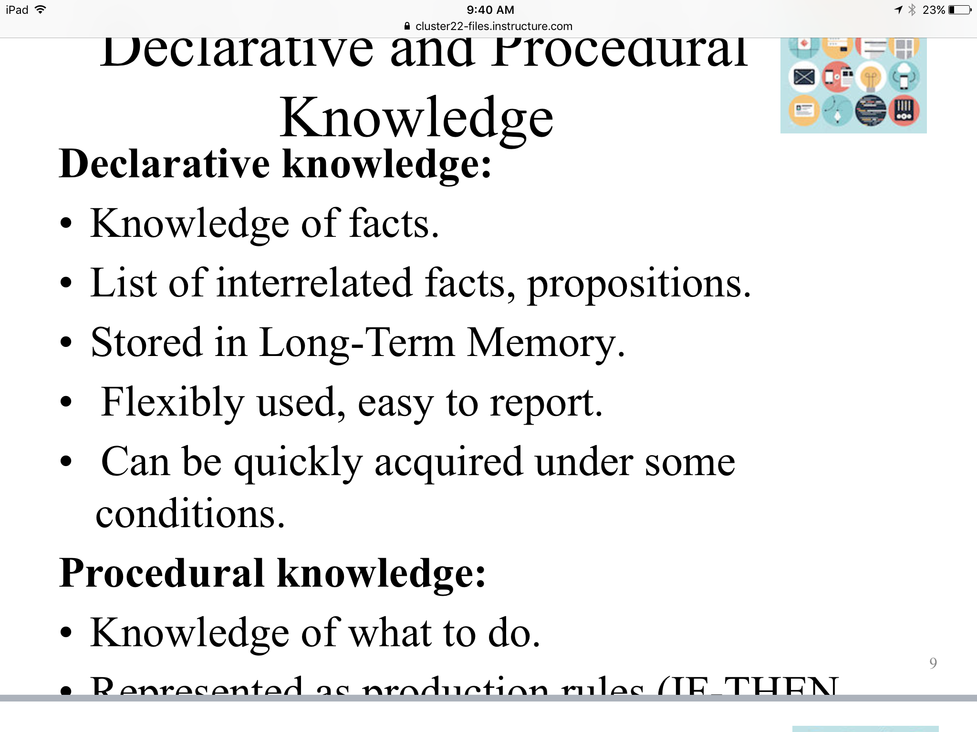

This is how the above it supposed to be displayed:
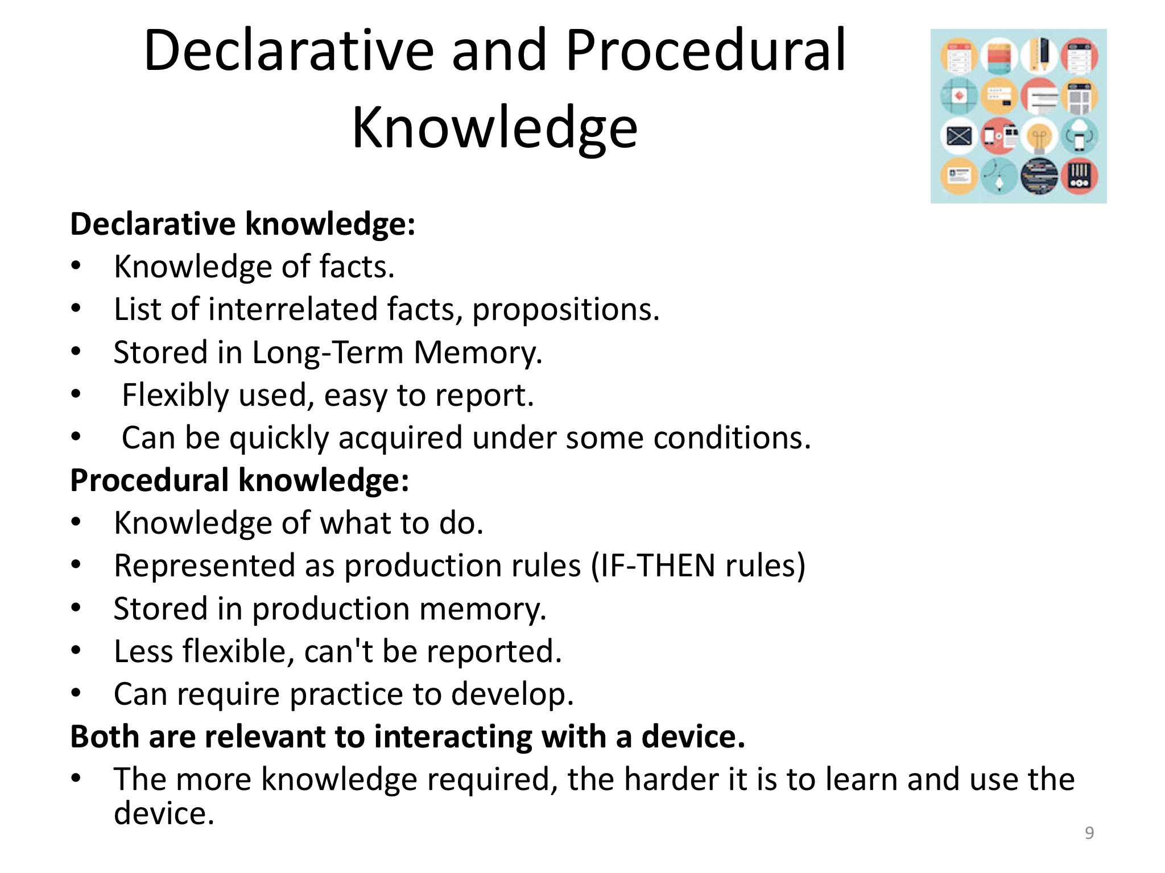
For my project, I started to look at several designs with a simple and clean look. I found two versions of this. One is from www.templatemo.com and it uses a one-page theme based on jQuery horizontal scrolling pages. The icons and menus are incorporated in the center of the page, since my site will include menus such as Inventory, My Request, My Work Orders, My Profile this seems to be a good choice: (http://www.templatemo.com/tm-359-singular)

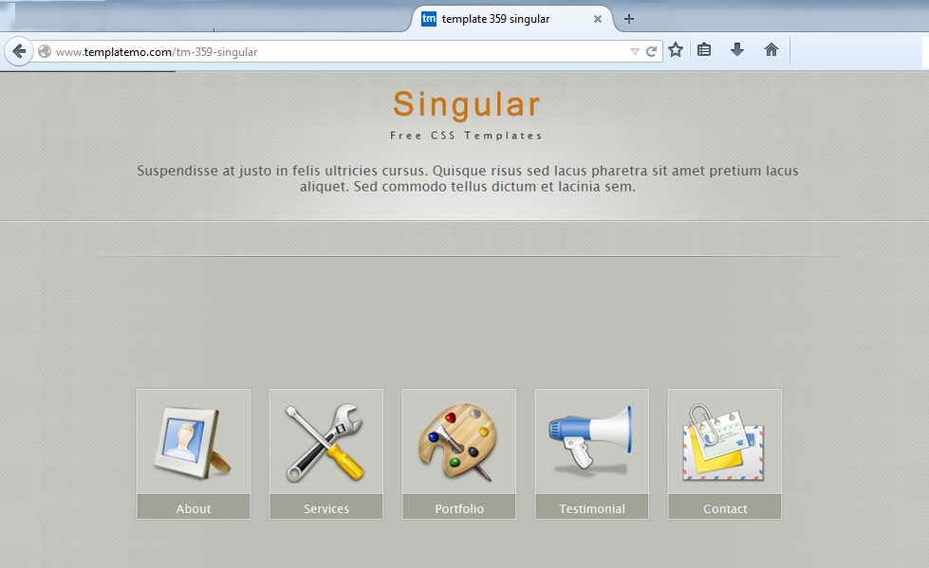
Another site sample that looks promising as a good fit for my project is “Lime Green”. This particular example is more interactive and the menus change color as the user hovers around them giving that feedback the important. I also like the format layout for the content. Lime Green (http://www.free-css.com/free-css-templates/page13/lime-green) is a CSS based.:

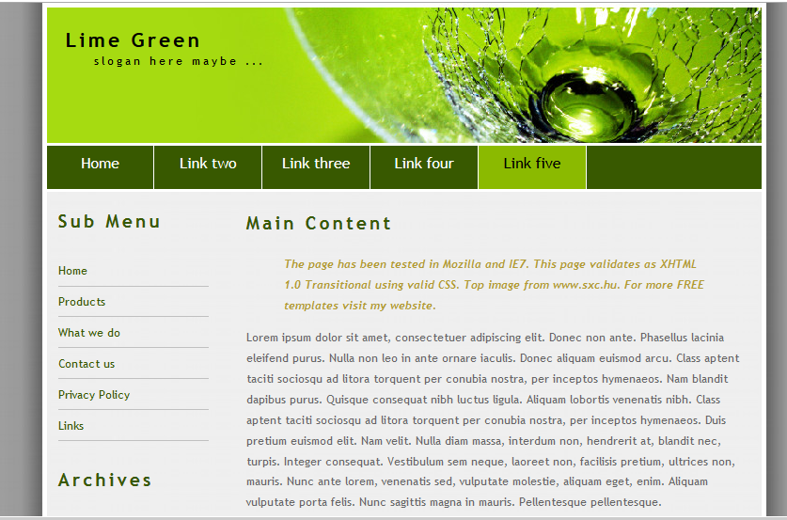

The entrance page for my project will be the Login Page and I’m simply looking for the user id field and password field with the standard feedback and validation components. Once user is validated one of these pages above will become the main menu.

Another good example of simple and practical design that I found was with a new wearable device I just purchased for walking and running. This footpod is made by Milestonepod and consists of the app and a small round device that is attached to the shoelace.

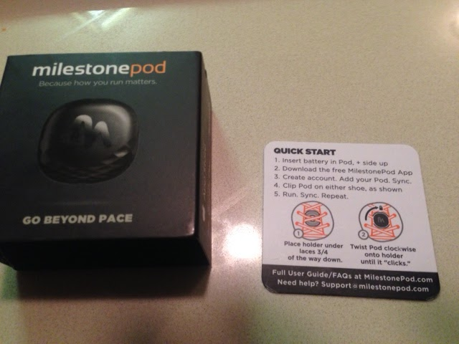

The instructions are only 5 steps, the configuration for the device in the app was almost instantly, the icons in the app are simple to understand with an easy interface
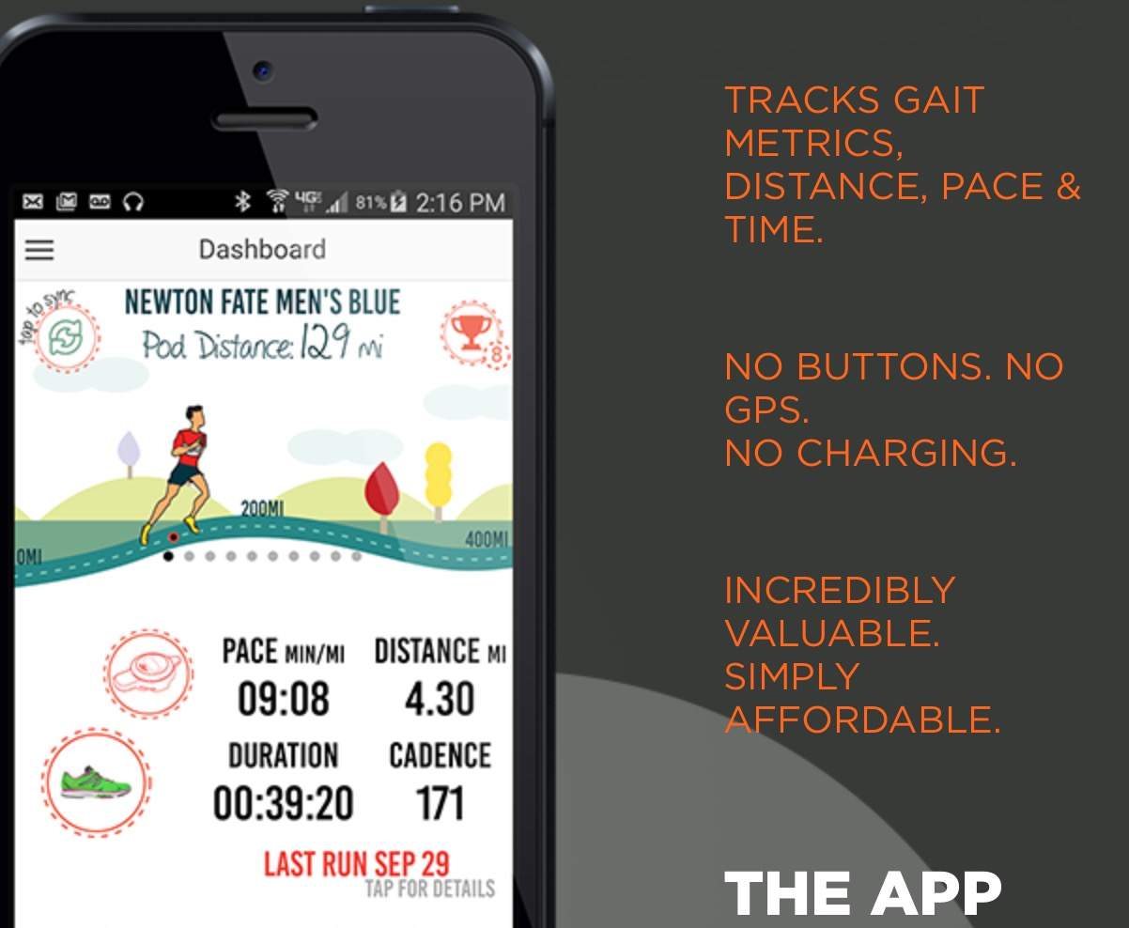

Their website is built in the very same way, for my project I want to keep this example as one of my guidelines

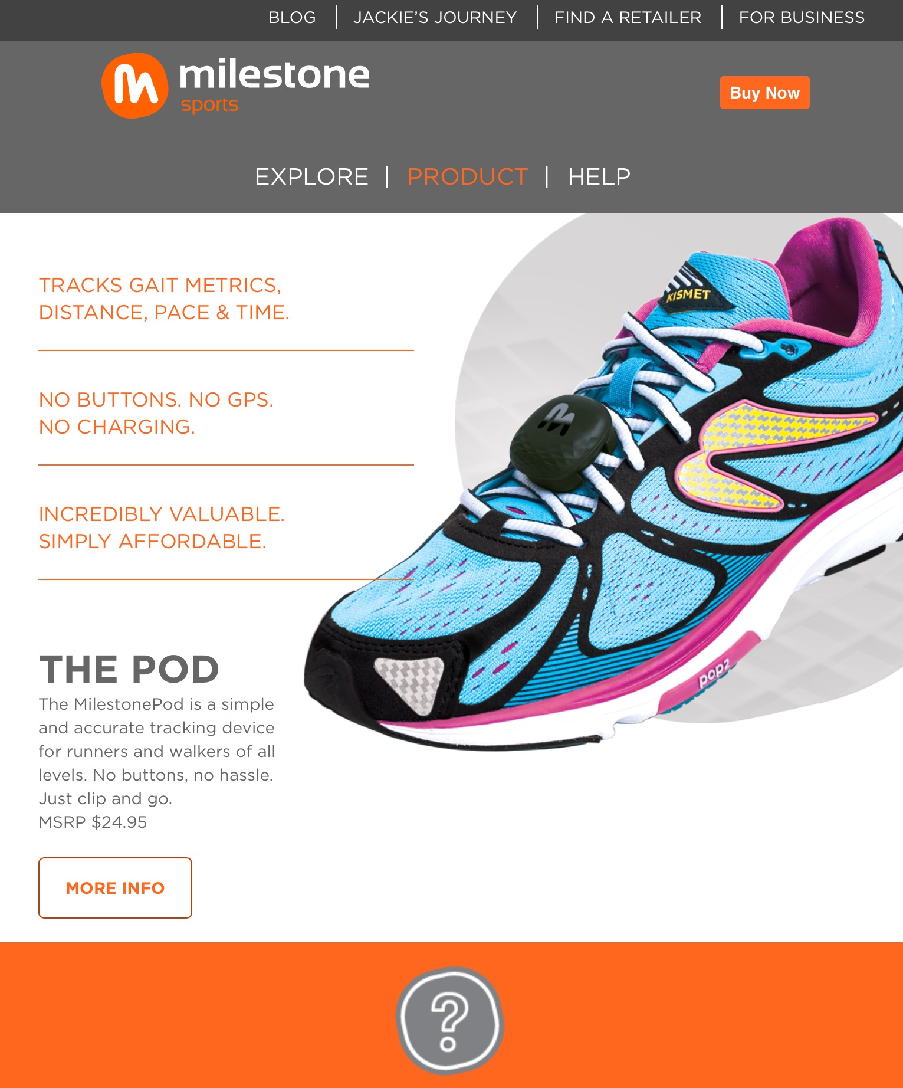

As you can see, the site contains four external links and three main menus, excellent design.

