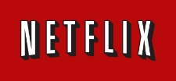
Humberto Espino
IM 701
Case Study: Netflix, Inc.

Introduction- who is Netflix?
Companies may become exceptionally successful by focusing on a small segment of a customer market as it has been the case for Netflix. This company is now the world’s leading Internet television network with over 83 million members in over 190 countries enjoying more than 125 million hours of TV shows and movies per day, including original series, documentaries and feature films. Its members can watch as much as they want, anytime, anywhere, on nearly any Internet-connected screen. Members can play, pause and resume watching, all without commercials or commitments (Company Profile, 2016).
Background - what need is the company trying to address?
Netflix, Inc. was established in 1997 by their founder Reed Hastings as a movie rental service. Netflix employed then and continues to employ a subscription based business model. This company began as web-based catalog service that was only a DVD-by-mail service. Customers paid a $19.95 per month subscription and received three DVDs by mail from the top of their list, with no return deadline or late charge. DVD’s were retuned in postage-paid enveloped before receiving the next titles on their list. After a couple of years, the company began streaming services along with the DVD-by-mail option.
Strategy and Leadership – how successfully the company addressed the problem or need?
The key to success for Netflix has not been simple. At first, direct competition came from Blockbuster and Wal-Mart (Walmart), with both companies having similar rental services including the sales of physical movies and videos, however Netflix focused on rental alone. In 2000, Reed Hastings approached former Blockbuster CEO John Antioco and asked for $50 million dollars for Netflix, Antioco declined (Chong 2015) Blockbuster went bankrupt in 2010. By 2005 Amazon.com announced its entry to the market causing its competitors to rethink their capital venture… “Wal-Mart Stores, the world's largest retailer, said today that it would no longer offer online DVD rentals and would instead direct its customers to Netflix, a startup company whose business model it copied” (Bayotmay 2005).

Opportunities - how information management help the company improve its performance and product(s)?
One of the driving forces for Netflix was Hastings. He saw thru the use of information management the opportunity and the value of market trends. Hastings was able to understand that in home viewing of movies was consistently growing, and Netflix took the risk and decision to make changes to their business model. The streaming option began in 2007, with a catalog of 2,000 titles available for instant-viewing via streaming, and rapidly expanding this catalog to 20,000 by 2010. In a short time, Netflix became the largest and most well-known internet subscription streaming service, and were able to have a solid business within in the market and hold a majority of subscribers.
By 2010, Netflix entered a new level a competitive on-demand marketplace dominated by Apple, MovieLink, CinemaNow and cable companies, nonetheless Netflix’s competitive edge and business plan has proved to be successful.
- Netflix made deals with Disney, CBS and Epix for TV content, and with Relativity Media and others for movies
- Netflix introduced an “all-you-can-watch” service for $8.99 per month
- Netflix introduced an “unlimited TV and movies streaming service to computer and TV
- Separated the online streaming and DVD by mail services
(Hartung 2013)

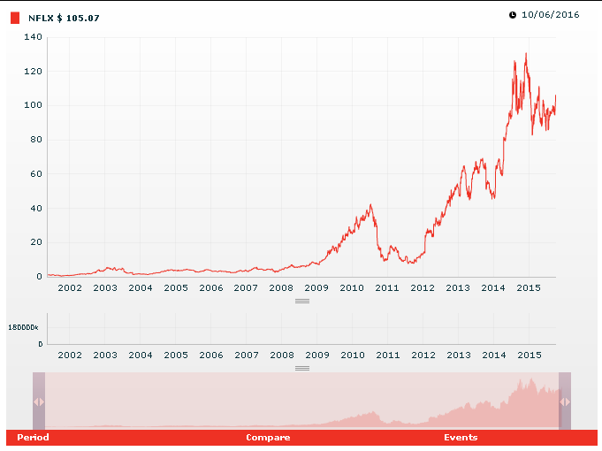
Figure 1
“The stock information provided is for informational purposes only and is not intended for trading purposes. The stock information is provided by eSignal, stock charts are provided by NASDAQ OMX, both third party services, and Netflix does not maintain or provide information directly to this service. Stock information is delayed approximately 20 minutes.” (Netflix 2016)
Risk Management – Procedures, Regulations, and Policy| missteps or missing steps?
Rising competition, and pressure for rapid growth are examples for how a company needs to constantly reinvent their business model strategically, however there is a balance and a learning curve. For Netflix, the core strategy of streaming video was to reduce cost by trying to get the costumer to favor this new option which would reduce the cost on postage, mailing, shipping materials and DVDs. Netflix continued to domestically grow and began their international expansion first with Canada in 2010, and a year later initiated their streaming services to 43 countries worldwide. Their mail services were kept only for the North America market. (Netflix- Annual Meeting of Stockholders 2016)
Netflix’s risk management is not always been utilitarian, and as their market turned global the company was faced new challenges. In 2011 Netflix made a decision to change their business model, the plan was to split the subscription plan that offered the option of streaming and DVD-by-mail service. In its place, these services would be offered in two separate packages. This announcement immediately created a negative response from both, their current customers and the stock market. As a result, customers started to flee and Netflix made the decision to only keep offering streaming services through the name Netflix, Inc. and all mail services were moved to a website called Qwikster.com. This later move caused an uproar from the company’s customers and the stock market, as shown in figure 1 the drastic stock plunged for 2011 in such a short time. …” NEW YORK (CNNMoney) -- The Netflix nightmare continues. Shares plunged 35% on Tuesday after the video service revealed that it lost 800,000 subscribers in its difficult third quarter.” (Pepitone 2011). Due to the controversy and negativity, the proposed change was abandoned, however the stock price continued to drop. In the same year Netflix announced the sale of $400 million dollars in stock as a way to acquire new capital, but once again this risk only added more troubles to the company and their stock price dropped again considerably figure 1.
Lessons Learned – Is the company user-centered?
By 2012, Netflix’s troubles started to change and a new strategy started to merge. With over 23 million subscribers and around 120,000 titles for online streaming at the time, the CEO of Netflix, Reed Hastings developed a strategy which made this company the largest online subscription service for streaming entertainment in the world.
Netflix’s strategy includes:
- Providing customer with a wide selection of DVD titles to view.
- Continually acquiring new content by establishing new relationships with entertainment providers
- Provide easy to use technology for costumers to order and identify what they wish to view
- Provide options for subscribers between streaming and mail services
- An aggressive marketing and brand awareness that clearly describes the added-value of service
- Promote rapid transition of domestic subscribers to streaming
- Expand internationally (Hartung 2013)

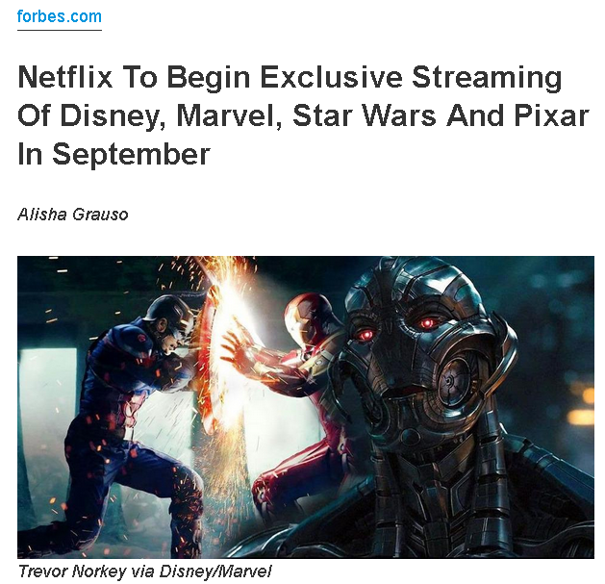
(Grauso 2016)
Strengths and Weaknesses - Is the value of the service clear? | Does the company have the technological infrastructure in place for growth?
Since the beginning and under Hastings’ leadership, Netflix has chosen to surpass their competitors on the basis of differentiation by offering a wider product selection, value-added services and attractive style. Hastings had focus on gaining new content to make available to subscribers. He has made negotiations with all major studios and networks and usually paid full licensing fees, and at times had made profit-sharing deals in order to be able to stream these titles to its customers.
With regard technology innovation, Netflix is not fixed or committed to a single device, as this is also true for content management and storage as they utilize Amazon- AWS cloud computing services. To the contrary, they continue to enter new technology markets as they are made available. The proprietary software technology of Netflix is a large part of their strategy. The software made easy for a subscriber to preview movies based on category, rating and other filters acts a simple intuitive tool for the user. In addition, Netflix has implemented a smart-way of using subscribers as “content expert” by allowing them to rate the titles of movies they have previously watched and receive recommendations from others on titles that were previously rated high.
Netflix’s Technology Infrastructure: (Ueland 2015)

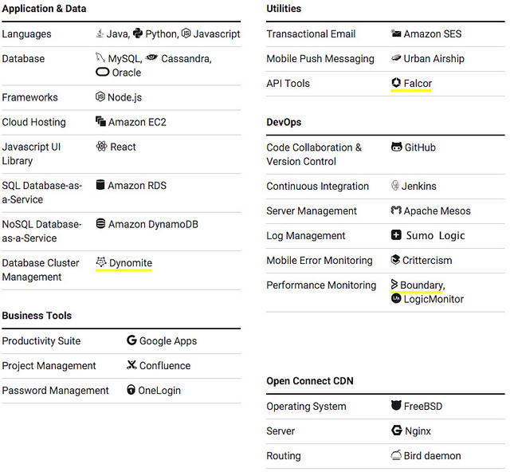
Profitability – Is the right balance between innovation risk and loss/failure maintained?
The strategy of allowing a customer to rate content, continues to be highly successful with a good portion of titles being viewed coming from recommendations provided. Furthermore, product availability based on rating ensures customer satisfaction as high rating titles are always available for physical DVDs for those subscribers who choose DVD-by-mail over streaming services. As part of their growth, Netflix continues to aggressively market and advertise into newly entered countries, offering free trials to all new costumers which consist of a free month of access to services and are allowing payments to consumer to electronics partners.

The strategy to increase profits for the Netflix continues to be through international expansions. However, no all foreign markets have the infrastructure in place for Netflix’s business model. In Latin America, for example, they ran into multiple issues with lack of internet capable devices, high-speed internet connections and credit cards not readily available or used for e-commerce purposes. Nevertheless, the company continues to move forward into new markets and have had considerable success in many areas.
Recommendations – Policy, Technology, Content, and People | what procedures, laws, technology or regulations need to be considered to help the company move forward?
Their success and effectiveness on the movie-rental industry for Netflix will depend in the ability to take their enterprise to the next level and the adaptability to the rapid shifting on technology and consumer demands. The wave of the future for renting movies and the way TV content is delivered via streaming is clear, linear TV viewing and movie watching as we know it today will be over within the next few years. Streaming has the advantage to order and instantly watch what the consumer wants. With recent advances in video-streaming technology is rapidly improving the prospects that Video-on-Demand will merge as the dominant movie rental. Netflix’s new business systems, organizational design, and strategies will have to evolve as a result. Many of the opportunities for Netflix’s growth are set around parameters such as, increasing infrastructure capacity; mobile internet segment; international expansion; independent studios; atomization of content predictable-systems; revenue sharing agreements; and Netflix ready devices.
By increasing their infrastructure capacity, Netflix is guaranteeing long-term preservation of current and new product. Likewise, as the number of mobile internet segment grows, so is Netflix’s customer base for both at the international level and the domestic level. Another important factor is the ability to create original and independent content, particularly when dealing with a diverse population where customer needs can be very unique to their country of origin. This also plays along with predictable systems that can identify or recommend product based on culture or regions. There is no question that the aggressive negotiations to obtain licensing of content thru either sharing agreements or others will continue to be a big factor of growth, and lastly the proliferation of Netflix ready devices will only increase their opportunities for expansion in the Online streaming business.

Currently, Netflix’s organization consists of …” As of December 31, 2015, we had approximately 3,700 total employees. Of these employees, approximately 3,500 were full-time, including approximately 400 categorized as temporary.” As for intellectual property Netflix…” We regard our trademarks, service marks, copyrights, patents, domain names, trade dress, trade secrets, proprietary technologies and similar intellectual property as important to our success. We use a combination of patent, trademark, copyright and trade secret laws and confidentiality agreements to protect our proprietary intellectual property. Our ability to protect and enforce our intellectual property rights is subject to certain risks and from time to time we encounter disputes over rights and obligations concerning intellectual property. We cannot provide assurance that we will prevail in any intellectual property disputes” (Netflix- Annual Meeting of Stockholders 2016).

One of the biggest risks for a company working at a global market level such as Netflix is the amount of resources and management that is required to maintain its edge. Political and economic factors are also contributors to this risk. Netflix clearly understands and are aware of these issues as they are stated in their annual report 2015…”Our failure to manage any of these risks successfully could harm our international operations and our overall business, and results of our operations. If we fail to maintain or, in new markets establish, a positive reputation with consumers concerning our service, including the content we offer, we may not be able to attract or retain members, and our operating results may be adversely affected” (Netflix- Annual Meeting of Stockholders 2016).

In order for Netflix to continue to be successful in an Online setting for a global market, a set of several recommendations need to be followed that either need reinforcement or need close attention. One of these recommendations is that in order to resolve difficulties and costs associated with staffing and the managing for their foreign operations, is to maintain local, qualified and skilled personnel at all levels of the organization. Keep at minimum management distractions due to unnecessary competing strategies. Have a strategic and tactical plan that addresses potential political or social unrest and economic instability for each area of country of operation. Ensure strict compliance with U.S. laws such as the Foreign Corrupt Practices Act. Stakeholders must understand regulatory requirements of operation and the consequences of violating controls and economic sanctions, and understand compliance of local laws, regulations and customs in foreign jurisdictions. Rather than compete with Itunes, strengthen its partnership with Apple to a single distribution channel. Redefine their exit strategy for the DVD-by-mail business. Partner with Multichannel Television providers to offer their streaming content and directly compete with Cable and Satellite providers. Imitate HBO model and adding more expensive movie series to their streaming services. Continue with the expansion of the international market, particularly China, and lastly to create additional value to customers leverage mobile 3D technology across multiple platforms such as oculus.

Bibliography: Netflix, Inc.

“Company Profile.” www.ir.netflix.com/index.cfm. Accessed 6 October 2016.
Bayotmay, Jennifer. May 19 2005. “Netflix Takes Over Wal-Mart's Online DVD Rental Business.” www.nytimes.com/2005/05/19/business/media/netflix-takes-over-walmarts-online-dvd-rental-business.html. Accessed 7 October 2016.
Chong, Celena. July 17 2015. “Blockbuster's CEO once passed up a chance to buy Netflix for only $50 million.”www.businessinsider.com/blockbuster-ceo-passed-up-chance-to-buy-netflix-for-50-million-2015-7. Accessed 9 October 2016.
Grauso, Alisha. May 24 2016. “Netflix To Begin Exclusive Streaming Of Disney, Marvel, Star Wars And Pixar In September.”www.forbes.com/sites/alishagrauso/2016/05/24/netflix-to-begin-exclusive-streaming-of-disney-marvel-star-wars-and-pixar-in-september/#151e3a8f322b. Accessed 6 October 2016.
Netflix. Oct 7 2016.”Stock Quote & Chart.” www.ir.netflix.com/stockquote.cfm. Accessed 8 October 2016.
Annual Meeting of Stockholders. June 9 2016. "Netflix - 2015 Annual Report & Proxy Statement." www.ir.netflix.com/annuals.cfm. Accessed 8 October 2016.
Pepitone, Julianne. October 25 2011. "Netflix stock sinks 35% as subscribers flee." www.money.cnn.com/2011/10/25/technology/netflix_stock/ Stock plunges 35% 2011. Accessed 8 October 2016.
Hartung, Adam January 29 2013. “Netflix - The Turnaround Story of 2012!.”www.forbes.com/sites/adamhartung/2013/01/29/netflix-the-turnaround-story-of-2012/#48eddfa42246. Accessed 8 October 2016.
Ueland, Chris. Nov 9 2015.” A 360 Degree View of the Entire Netflix Stack.” www.highscalability.com/blog/2015/11/9/a-360-degree-view-of-the-entire-netflix-stack.html. Accessed 8 October 2016.

