Humberto Espino
Assignment Two:
Dominican University stands at No. 19 in the U.S. News & World Report rankings this year among 171 Midwest regional universities.
Please retrieve the list of all Illinois institutions, which ranked higher than or tied with Dominican. Save their names and homepage address (URLs) from the above mentioned resource (1%).
Regional Universities Midwest
Rank | Name | URL
#23 | Lewis University | http://lewisu.edu
#19 | Dominican University | http://www.dom.edu
#11 | Elmhurst College | https://www.elmhurst.edu
#10 | North Central College | https://www.northcentralcollege.edu
For this assignment, we will evaluate these schools by their online visibility, traffic & social media data (using the tools we introduced to retrieve the publicly accessible ones) Use tables to store your data and list them as appendix. (9%)
Ranking based on online visibility:
Alexa | Semrush | Similarweb
North Central College | Elmhurst College | North Central College
Dominican University | North Central College | Dominican University
Lewis University | Lewis University | Lewis University
Elmhurst College | Dominican University | Elmhurst College
Ranking based on traffic:
Alexa | Similarweb | Semrush
Lewis University | Lewis University | Lewis University
Dominican University | North Central College | North Central College
North Central College | Dominican University | Elmhurst College
Elmhurst College | Elmhurst College | Dominican University
Ranking based on social media:
Similarweb
Lewis University
Dominican University
North Central College
Elmhurst College

You need to compare the "Alternate rankings" with the US News & World Reports one. Can we use the free online information as an alternative benchmark to rank universities belonging to the same category? Why? (10%)
The answer to this question is No. When comparing Alternate rankings and US News & World Reports are very different. While the US News & World Reports use a specific approach to their research, the alternate rankings have a number of metrics that are not necessarily standard. Also the metrics used in the alternative benchmarking tend be a bit inflated in my view, for example the most clicks to a specific part of the site is not an indication of popularity, and it can be an indication of poor design. Someone might be looking for a specific page that is not easily accessible in the site and therefore more clicks. I would use US News & World Reports for a true raking and if I were looking at it from a marketing prospective, yes Alternate rankings will make more sense.
From the SEO and end/actual user's perspective (yes, your's personal impression is very important), which university/college's homepage is the best and why? (5%)
From my perspective, the sites that seem to me in the low ranking are North Central College and Lewis University. The both have a number of scrolling pictures from both sides which make both sites extremely busy, the menus above create a sense of overwhelm, if you are not careful where you click it will direct you to another part of the site.
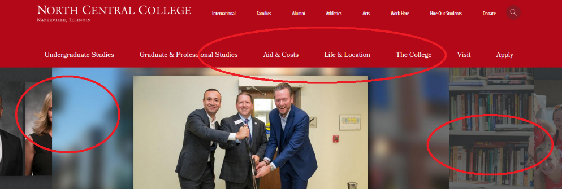
Elmhurst and Dominican in the other hand have a very clean main page. While Elmhurst have a very dynamic image that creates the illusion of a video, which does a very good job to catch the attention, the navigation for both sites is clean and intuitive. Personally Dominican has the best site when comparing to the other three, is simple to get from point A to point B and is not distracting as the others with all the video and extra-large images, particularly this could be a problem when you are using a mobile device, well structured design.
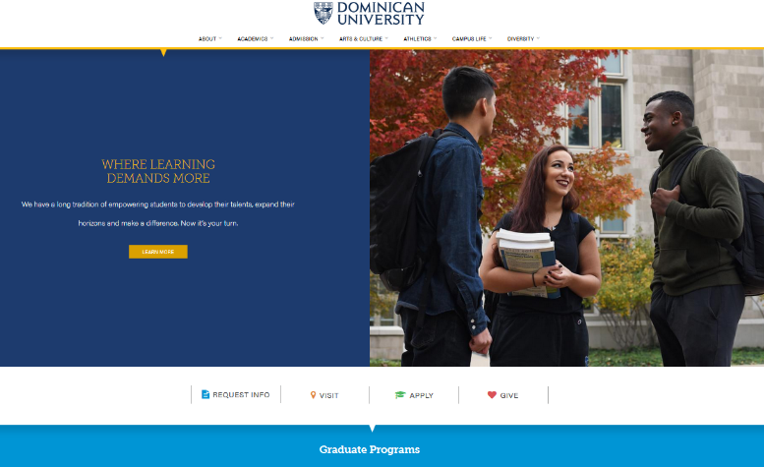
Appendix
Similarweb
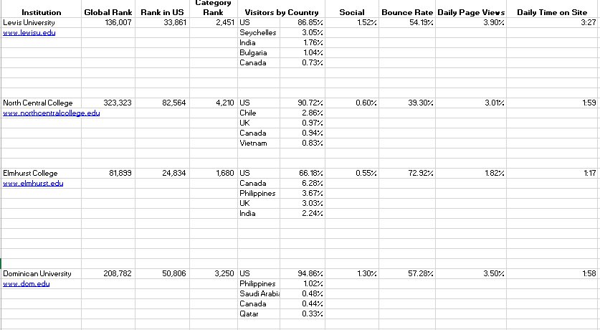
Alexa
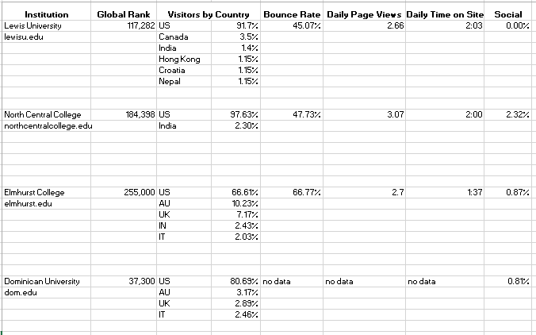

SEMrush
